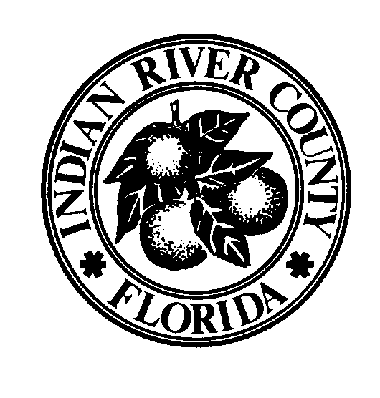

INDIAN RIVER COUNTY/CITY OF VERO BEACH

BUILDING DIVISION
1801 27th Street, Vero Beach, FL 32960 772 226-1260

NOTICE

From: Scott McAdam, CBO, MCP, Building Official
To: All Permit Applicants
Date: 1/3/2020
Subject: New Fuel Gas Permit Application

Effective Date: February 3, 2020

Requirements
- The new Fuel Gas Permit Application must be submitted as of the effective date indicated above. Please start using it now and replacing any old ones you have saved. Old application will not be accepted on or after 2/3/2020.
- New application package includes a specific Fuel Gas Permit Application a change from being included on the Various Trades Application, a Checklist of required documents, routing, Department of Health review when applicable, Flood Zone review when applicable, etc.
- There is also online a Fuel Gas Information Form which is a gas riser diagram pipe sizing document. In the recent past we started requiring this document. At this time it will not be required to be submitted but maybe requested by the Inspector if during the inspection it is found that the size and complexity of the system requires it, which will be on a case by case basis i.e. typical size simple system VS a larger custom home more involved system with greater BTU and pipe runs.

Information
- The Building Division will release additional notices as information is provided pertaining to significant Code, policy, and or form or application changes.
- It is essential that applicants, design professionals and contractors keep their eyes and ears open for information relating to Code, policy and or form or application changes. It is your responsibility to comply with the applicable Codes in effect for your project. The Building Division will attempt to keep you informed and updated to best of our ability.

